PROJECT 1
Title: Secure Private Infrastructure Deployment with Bastion Access and IAM Role-Based Architecture

1. Project Overview

Scenario
As a newly joined Cloud Engineer at a mid-sized fintech company, a security audit revealed that developers were directly exposing EC2 instances to the internet violating company security policies.
So,
"Design a secure infrastructure where application servers are completely private, no direct public access is allowed, and all access must follow least-privilege principles. Also ensure developers do not use access keys inside servers."

Objective
- Application servers run in private subnets
- No public IP assigned to backend servers
- Access is allowed only via Bastion Host
- EC2 instances use IAM Roles no hardcoded credentials
- Proper network routing and security isolation enforced

2. Architecture Overview
The following architecture was implemented:

Component | Type | Description
fintech-vpc | VPC | Custom VPC with CIDR 10.0.0.0/16
public-subnet-1/2 | Public Subnet | Hosts Bastion Host and NAT Gateway
private-subnet-1/2 | Private Subnet | Hosts Application Server (no public IP)
fintech-igw | Internet Gateway | Provides internet access to public subnets
fintech-nat | NAT Gateway | Allows private subnet outbound internet access
bastion-host | EC2 (Public) | Jump server only entry point to private network
app-server | EC2 (Private) | Application server with Nginx, no public IP
ec2-s3-readonly-role | IAM Role | Grants S3 read-only access without credentials

Traffic Flow
Access Flow: Local Machine → Bastion Host (Public IP) → App Server (Private IP)
Outbound Flow: App Server → NAT Gateway → Internet Gateway → Internet.

3. Implementation Steps

Step 1: Network Architecture Custom VPC
1.1 Create VPC
- Go to AWS Console → VPC → Create VPC
- Configure: Name = fintech-vpc, IPv4 CIDR = 10.0.0.0/16
- Click Create VPC
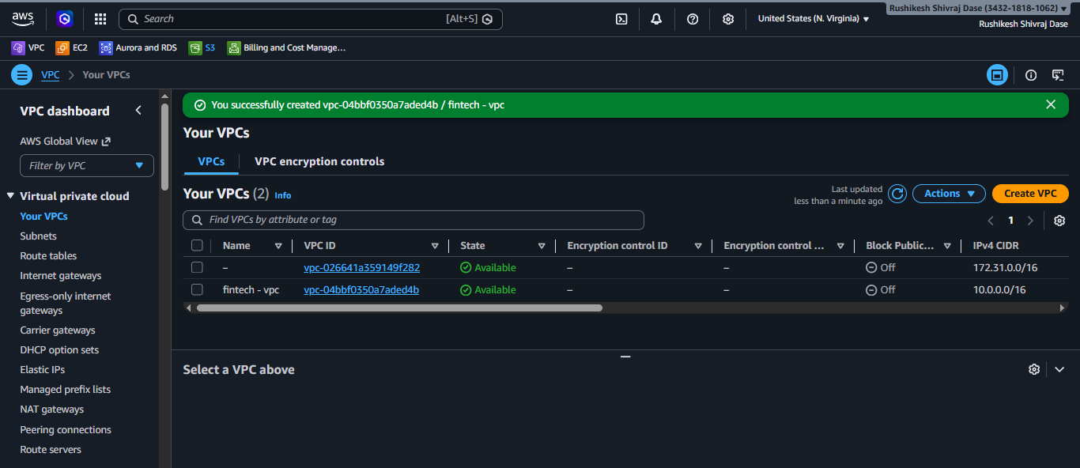
1.2 Create Subnets
Subnet Name | Type | Availability Zone | CIDR Block
public-subnet-1 | Public | ap-south-1a | 10.0.1.0/24
public-subnet-2 | Public | ap-south-1b | 10.0.2.0/24
private-subnet-1 | Private | ap-south-1a | 10.0.3.0/24
private-subnet-2 | Private | ap-south-1b | 10.0.4.0/24

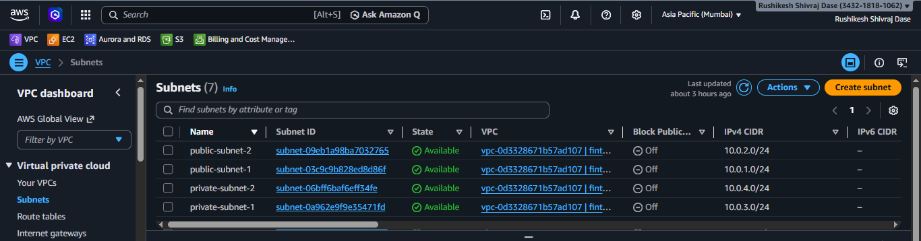

Note: For both public subnets, enable Auto-assign public IPv4 address = Yes

1.3 Internet Gateway
- Go to VPC → Internet Gateways → Create IGW
- Name: fintech-igw
- After creation → Attach to VPC → select fintech-vpc
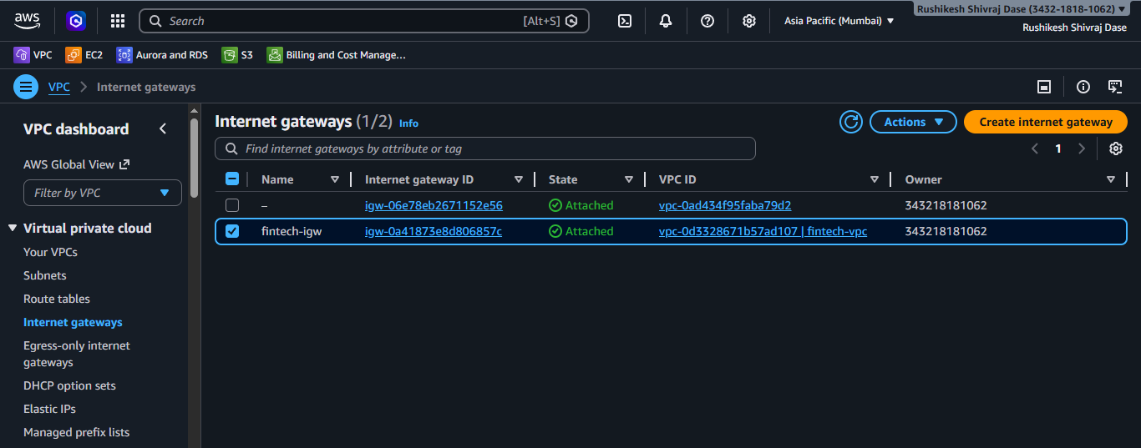
1.4 NAT Gateway
- Go to VPC → NAT Gateways → Create NAT Gateway
- Name: fintech-nat, Subnet: public-subnet-1
- Connectivity type: Public
- Method of Elastic IP allocation: Automatic
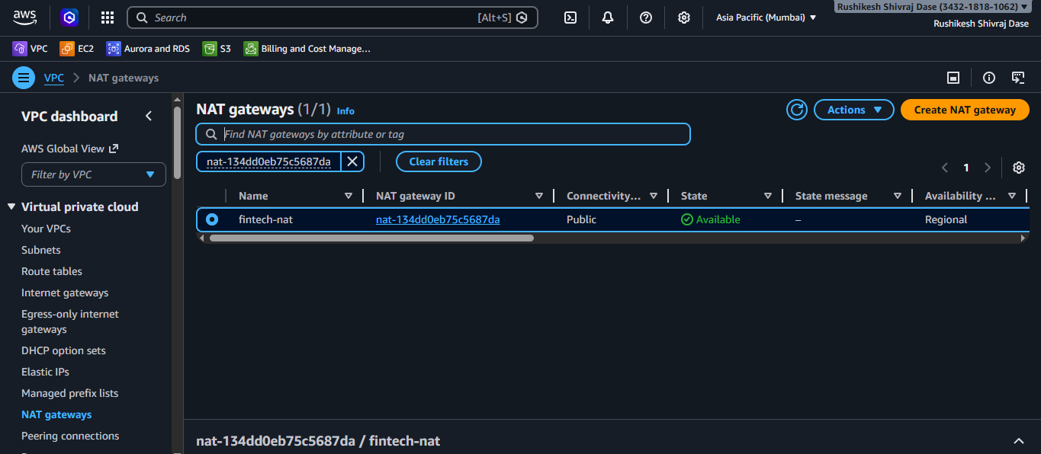
1.5 Route Tables
Public Route Table (public-rt):
- Create route table → Name: public-rt, VPC: fintech-vpc
- Edit Routes → Add: 0.0.0.0/0 → Target: fintech-igw
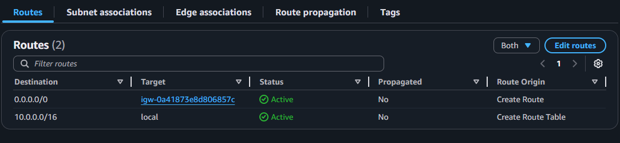

- Subnet Associations → associate public-subnet-1 and public-subnet-2
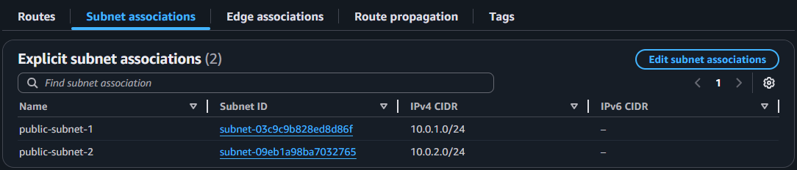
Private Route Table (private-rt):
- Create route table → Name: private-rt, VPC: fintech-vpc
- Edit Routes → Add: 0.0.0.0/0 → Target: fintech-nat
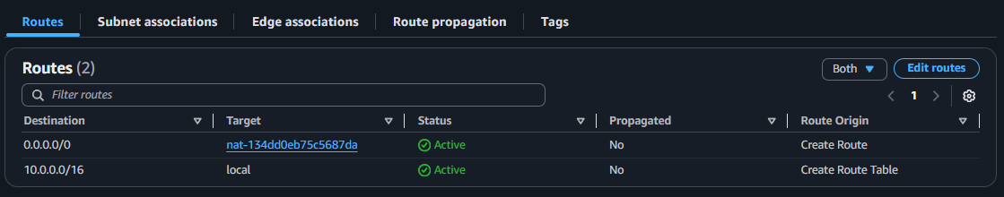
- Subnet Associations → associate private-subnet-1 and private-subnet-2
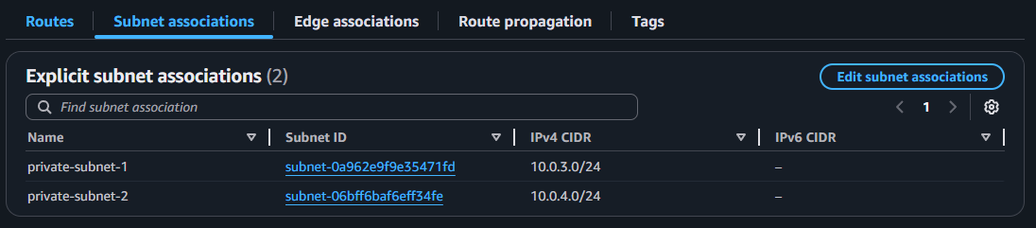

Step 2: Security Groups
2.1 Bastion Server Security Group (Bastion-sg)
Two security groups were created inside fintech-vpc:
- Go to EC2 → Security Groups → Create Security Group
- Fill in:
  - Name: bastion-sg
  - VPC: select fintech-vpc
- Under Inbound Rules → click Add Rule:
  - Type: SSH
  - Description: Allow SSH from my IP
  - Protocol: TCP
  - Port: 22
  - Source: select My IP from the dropdown → it auto-fills your current IP
- Click Create Security Group
# Note - we can also create it during launching ec2
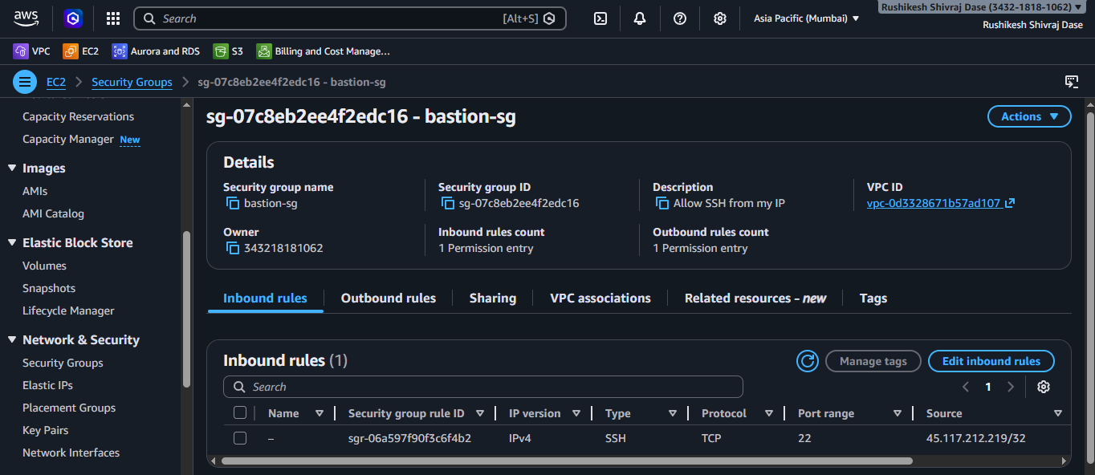
2.2 Application Server Security Group (app-sg)
- Create Security Group again
- Fill in:
  - Name: app-sg
  - Description: Allow SSH from Bastion and HTTP
  - VPC: select fintech-vpc
- Under Inbound Rules → click Add Rule twice:
Rule 1 (SSH from Bastion):
- Type: SSH
- Source: select Custom → in the search box type bastion → select bastion-sg from the dropdown
Rule 2 (HTTP):
- Type: HTTP
- Source: Anywhere-IPv4
- Click Create Security Group
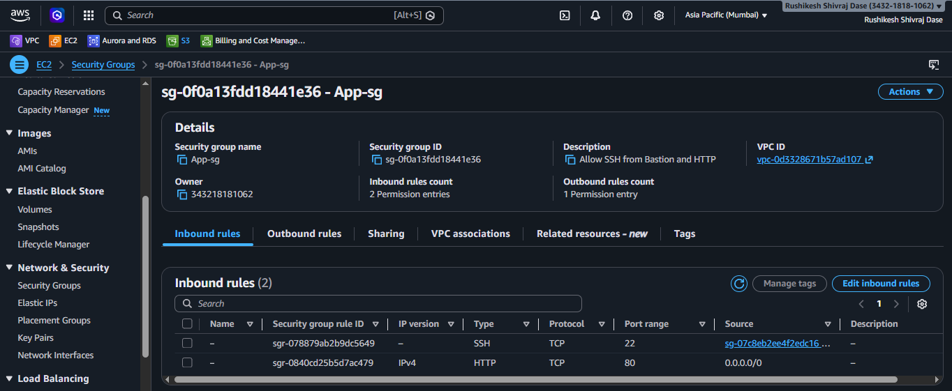
Security Design: Using bastion-sg as the SSH source means only the Bastion instance can reach the app server not any direct internet IP.

Step 3: EC2 Instance Launch
Setting | Bastion Host | App Server
Name | bastion-host | app-server
AMI | Amazon Linux 2023 | Amazon Linux 2023
Instance Type | t3.micro | t3.micro
Key Pair | m.linux.pem | m.linux.pem
VPC | fintech-vpc | fintech-vpc
Subnet | public-subnet-1 | private-subnet-1
Auto-assign Public IP | ✅ Enabled | ❌ Disabled
Security Group | bastion-sg | app-sg

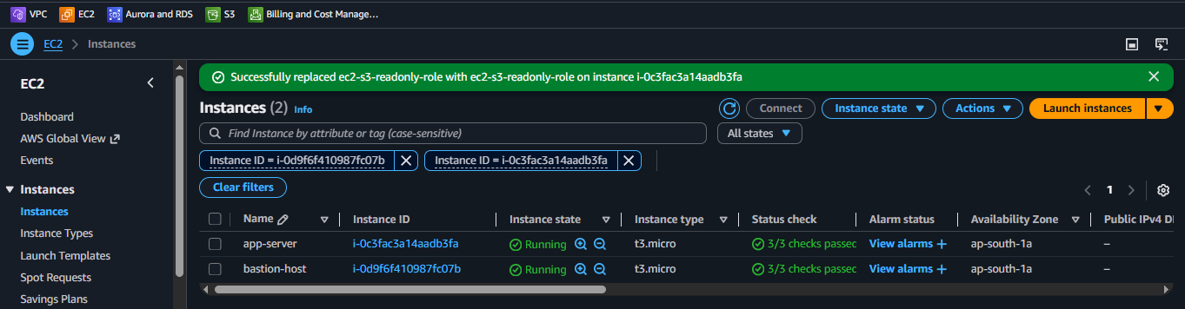

Step 4: IAM Role Implementation
4.1 Create IAM Role
- Go to IAM → Roles → Create Role
- Trusted Entity: AWS Service → EC2
- Permissions Policy: AmazonS3ReadOnlyAccess
- Role Name: ec2-s3-readonly-role
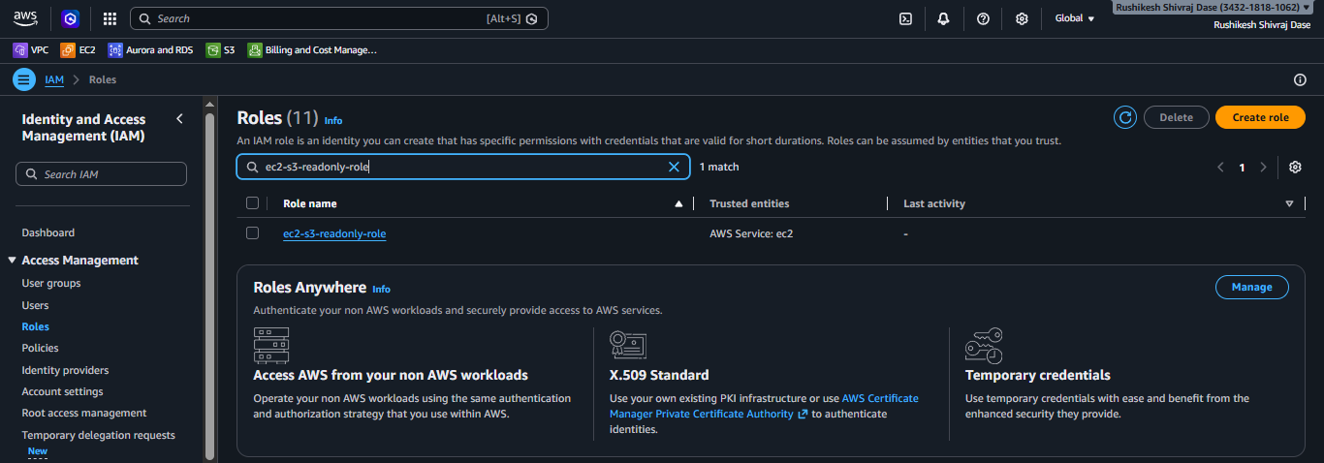
4.2 Attach Role to Private EC2
- Go to EC2 → select app-server → Actions → Security → Modify IAM Role
- Select ec2-s3-readonly-role → click Update IAM Role
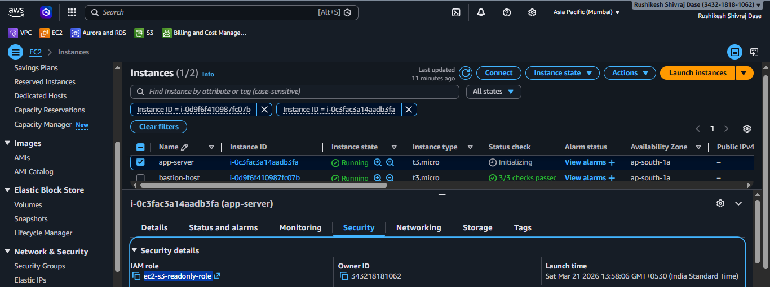

Step 5: Server Access & Application Setup
5.1 SSH Access via Bastion
Step 1 - Copy .pem key to Bastion (from local PowerShell):
scp -i .\Desktop\Pem\m.linux.pem .\Desktop\Pem\m.linux.pem ec2-user@<43.205.119.138>:.
Step 2 - SSH into Bastion:
ssh -i .\Desktop\Pem\m.linux.pem ec2-user@43.205.119.138
Step 3 - From Bastion, SSH into Private App Server:
ssh -i ~/m.linux.pem ec2-user@10.0.3.132
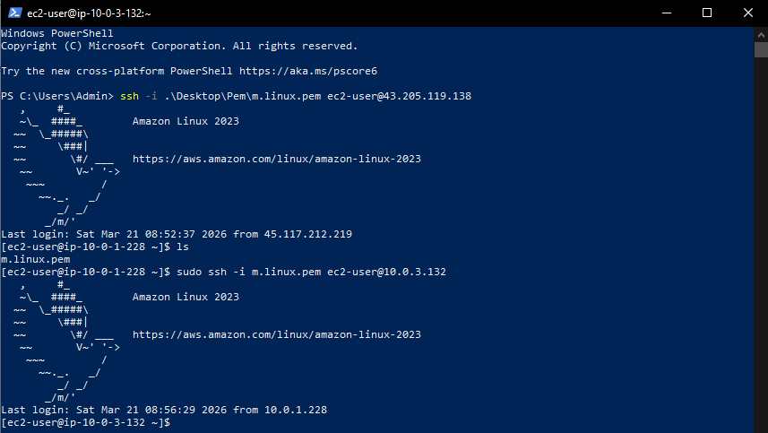

5.2 Install Nginx & Deploy Web Application
sudo dnf update -y
sudo dnf install nginx -y
sudo systemctl start nginx
sudo systemctl enable nginx
cd /usr/share/nginx/html
sudo nano index.html # Add sample web app content
sudo systemctl status nginx

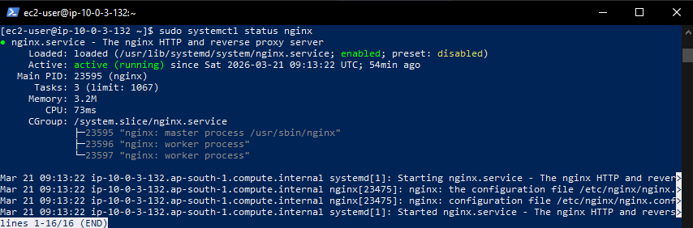

4. Security Validation

Validation 1: S3 Access Without Credentials
Command run on private server:
aws s3 ls
Result: All S3 buckets listed successfully it means IAM Role is working.
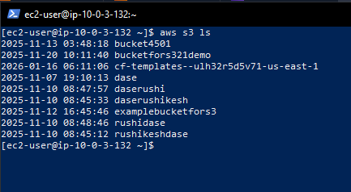

Validation 2: No Credentials Stored on Server
cat ~/.aws/credentials
Result: cat: /home/ec2-user/.aws/credentials: No such file or directory
This confirms no hardcoded access keys exist on the server.

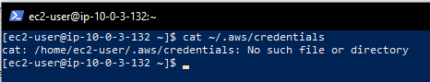

Validation 3: Private Instance Not Directly Accessible
Attempted direct SSH from local machine to private server IP:
ssh -i .\Desktop\Pem\m.linux.pem ec2-user@10.0.3.132
Result: Connection timed out private server is not reachable from the internet.

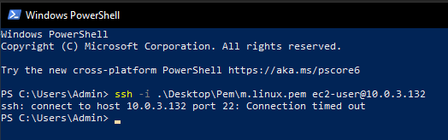

Validation 4: Only Bastion Allows SSH
SSH works only via Bastion jump:
# Step 1 Connect to Bastion (succeeds)
ssh -i .\Desktop\Pem\m.linux.pem ec2-user@43.205.119.138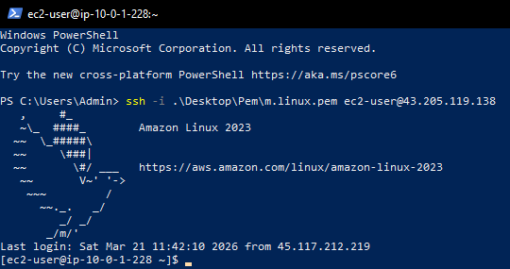
# Step 2 Jump to Private Server (succeeds)
ssh -i ~/m.linux.pem ec2-user@10.0.3.132
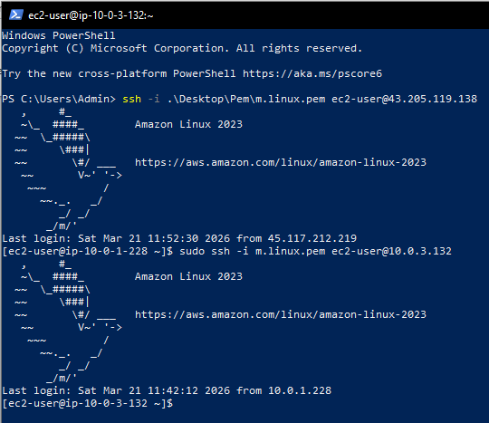
Validation 5: IAM Role Identity Verification
aws sts get-caller-identity
Result: ARN shows assumed-role/ec2-s3-readonly-role confirms role is attached and active.

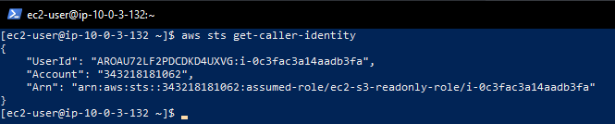

5. Architecture Explanation
The architecture follows a defence-in-depth security model:
- The VPC is divided into public and private tiers across two availability zones for high availability.
- The Bastion Host acts as the sole entry point for administrative SSH access, placed in the public subnet with a restricted security group allowing SSH only from the engineer's IP.
- The Application Server has no public IP and lives in a private subnet. Its security group only allows SSH from the Bastion's security group not from any IP address.
- The NAT Gateway allows the private server to reach the internet for updates and AWS API calls, but no inbound connections are possible.
- The IAM Role eliminates the need for access keys entirely the EC2 instance automatically assumes the role and can access S3 with read-only permissions.

6. Technologies Used
Service | Purpose
Amazon VPC | Custom network isolation with public/private subnets
Amazon EC2 | Bastion Host and Application Server instances
Internet Gateway | Public subnet internet connectivity
NAT Gateway | Private subnet outbound internet (no inbound)
IAM Role | Credential-free S3 access using instance profile
Amazon S3 | Storage service accessed via IAM role
Nginx | Web server installed on private application server
Security Groups | Firewall rules enforcing least-privilege access

7. Lessons Learned
- IAM Roles are always preferred over access keys for EC2 instances they are temporary, auto-rotated, and never stored on disk.
- Security Groups can reference other Security Groups as sources, which is more robust than IP-based rules.
- NAT Gateways require an Elastic IP and must be placed in a public subnet to function correctly.
- The SCP + SSH two-step method is a practical way to access private servers via a Bastion during development.
- Always verify security by attempting direct access a timeout confirms the private subnet is properly isolated.

8. Architecture Diagram

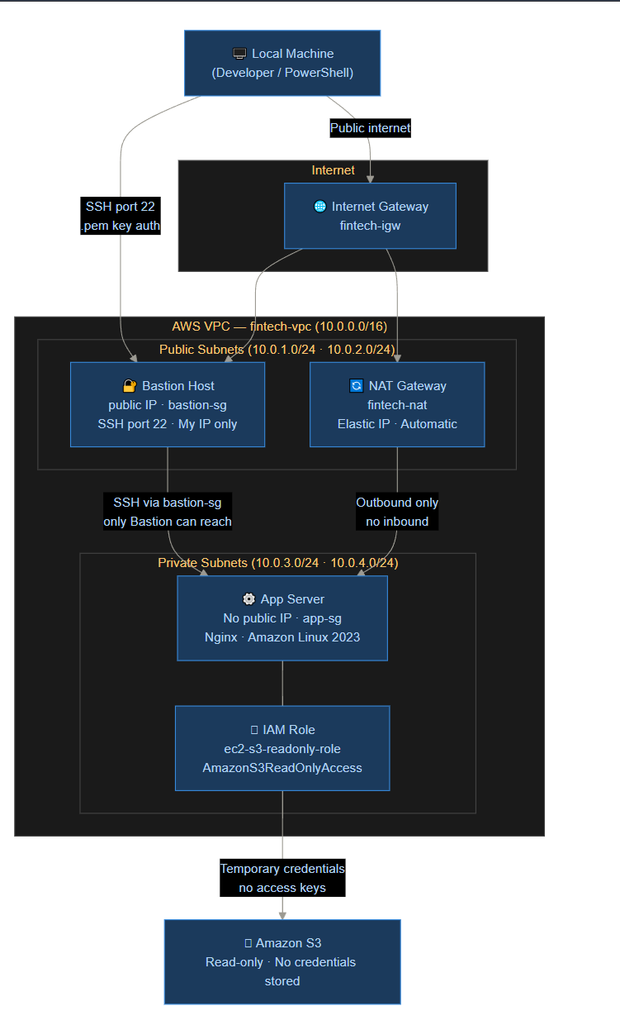

9. Security Design Decisions
No. | Decision | What We Did | Why
1 | No public IP on app server | Disabled auto-assign public IP | Eliminates direct internet attack surface completely
2 | SSH source = bastion-sg (not IP) | Used Security Group reference instead of IP in app-sg | Dynamic IP-safe; only the Bastion instance can SSH in, not any random address
3 | IAM Role instead of access keys | Attached ec2-s3-readonly-role to EC2 | Access keys can be stolen or leaked; roles are temporary and auto-rotated by AWS
4 | S3 Read-Only policy | Attached AmazonS3ReadOnlyAccess only | Least privilege app only needs to read, not create or delete buckets
5 | NAT Gateway in public subnet | Private EC2 routes outbound through NAT | Allows outbound updates/API calls but zero inbound connections possible
6 | Key-based SSH authentication | Used .pem key pair, no passwords | Brute-force resistant; passwords can be guessed, keys cannot
7 | Bastion SSH restricted to My IP | Source = x.x.x.x/32 in bastion-sg | Even if someone finds the Bastion's public IP, they can't SSH from a different IP

